|  |  |
| --- | --- |
| **Ex. No: 3** | **Form Making and Validation using JavaScript** |
| **27.07.2023** |

**Aim:**

To create a Form with usual form elements in JavaScript including the Alert(), Confirm(), and Response() functions. Additionally, validate the form elements.

**Algorithm:**

1. Create HTML and CSS file
2. Setup JavaScript in the HTML file
3. Access the form elements
4. Setup a validation logic
5. Use the Alert(), confirm() and response() functions for validation
6. Display validation results

**Program:**

HTML

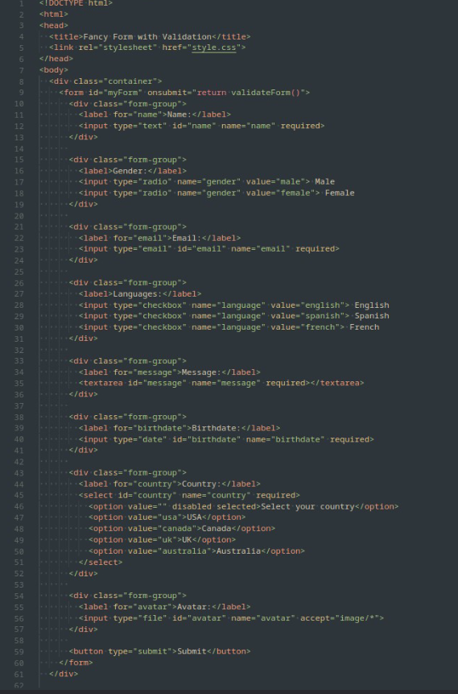

CSS

Javascript

**Output:**

Github Link: https://github.com/kavin-t28/CS3809-Web-Technologies-Lab

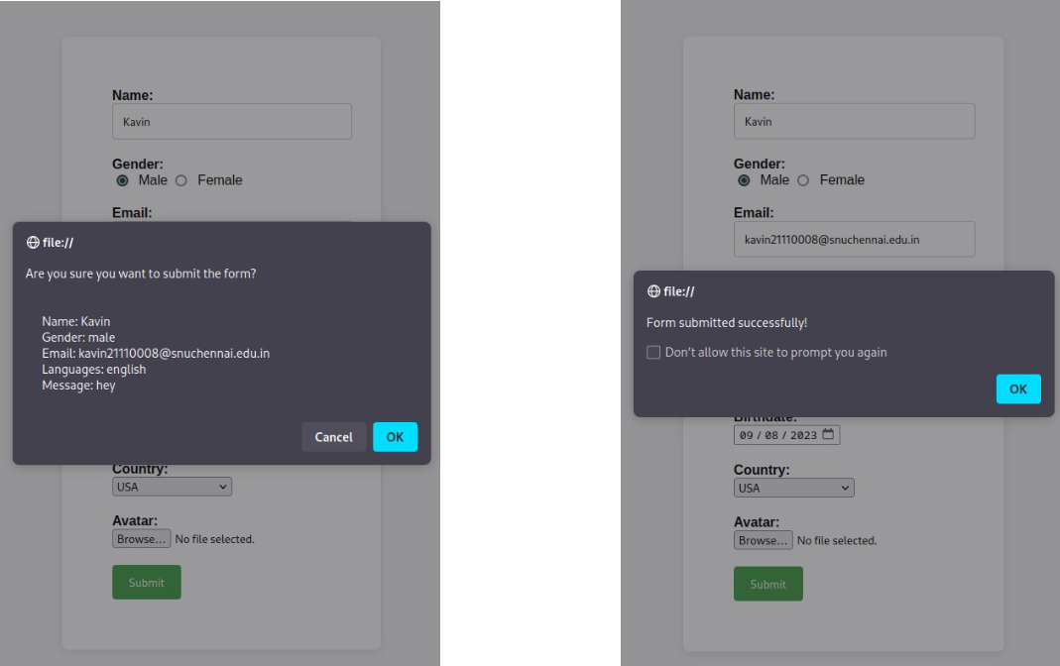

**Result:**

Therefore, created a form and validated it using javascript.